308 SW 2nd Street

Lindsay, OK 73052

Tel: (405) 756-1100 Fax: (405) 756-1104

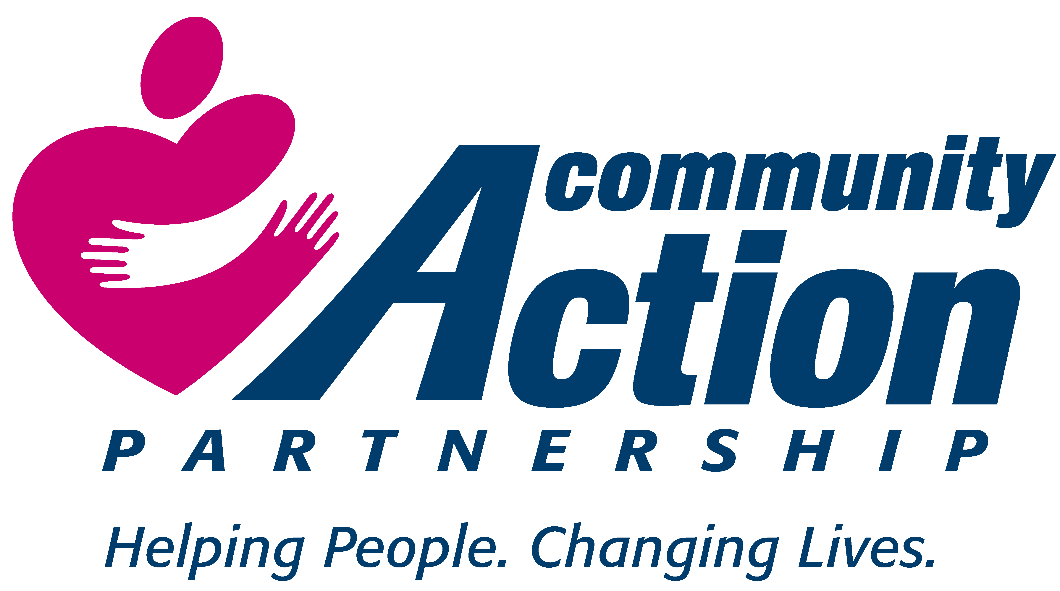

***Karen Nichols***

***Executive Director***

**DELTA COMMUNITY ACTION FOUNDATION, INC.**

**__________________________________________________________________________________________**

JOB OPENING

Senior Nutrition

Program Director

Will work out of Duncan Office

For questions or to submit application contact:

Karen Nichols

Executive Director

[knichols7@windstream.net](mailto:knichols7@windstream.net)

or

Jana Boyce

Human Resource

[jboyce@deltacaf.com](mailto:jboyce@deltacaf.com)

or call

(405) 756-1100

Job descriptions are available upon request.

Applications available at deltacaf.com

Post 4-4-2025